PSP0201

WEEK 2

WRITEUP

Day 1: Web exploitation – A Christmas Crisis

Walkthrough/solution

Question 1 :  Inspect the website. What is the title of the website?

* Registration and login page of Christmas Console. Register an account in the website to login.

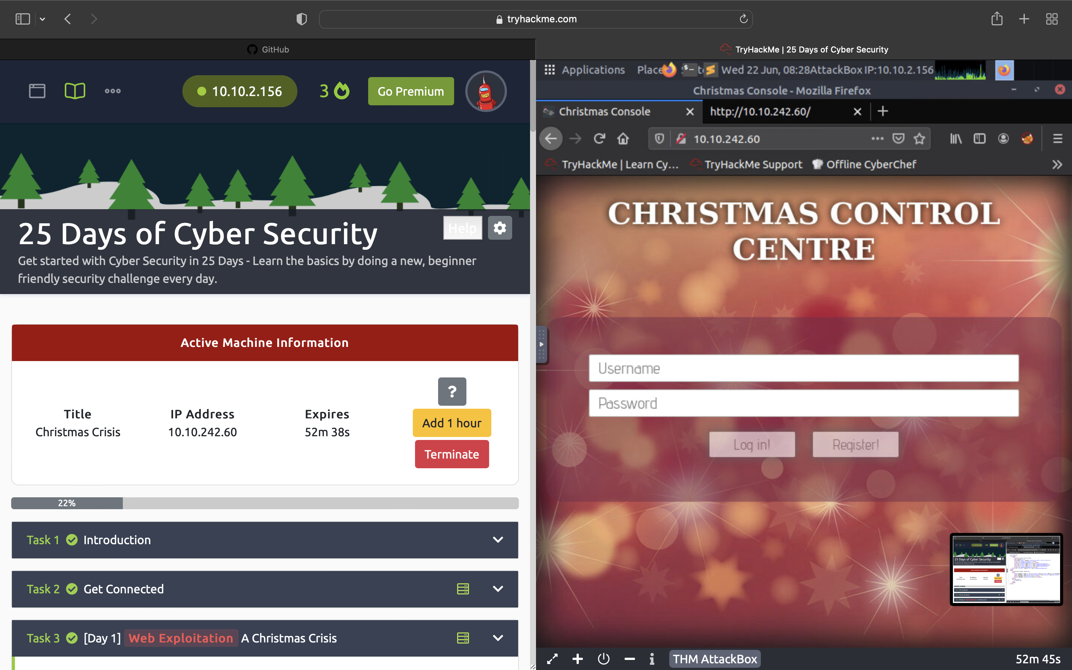

Question 2: What is the name of the cookie used for authentication?

* Once logged in the website, inspect the elements in the website to bring up the console. Navigate to the storage tab to obtain the auth cookie.

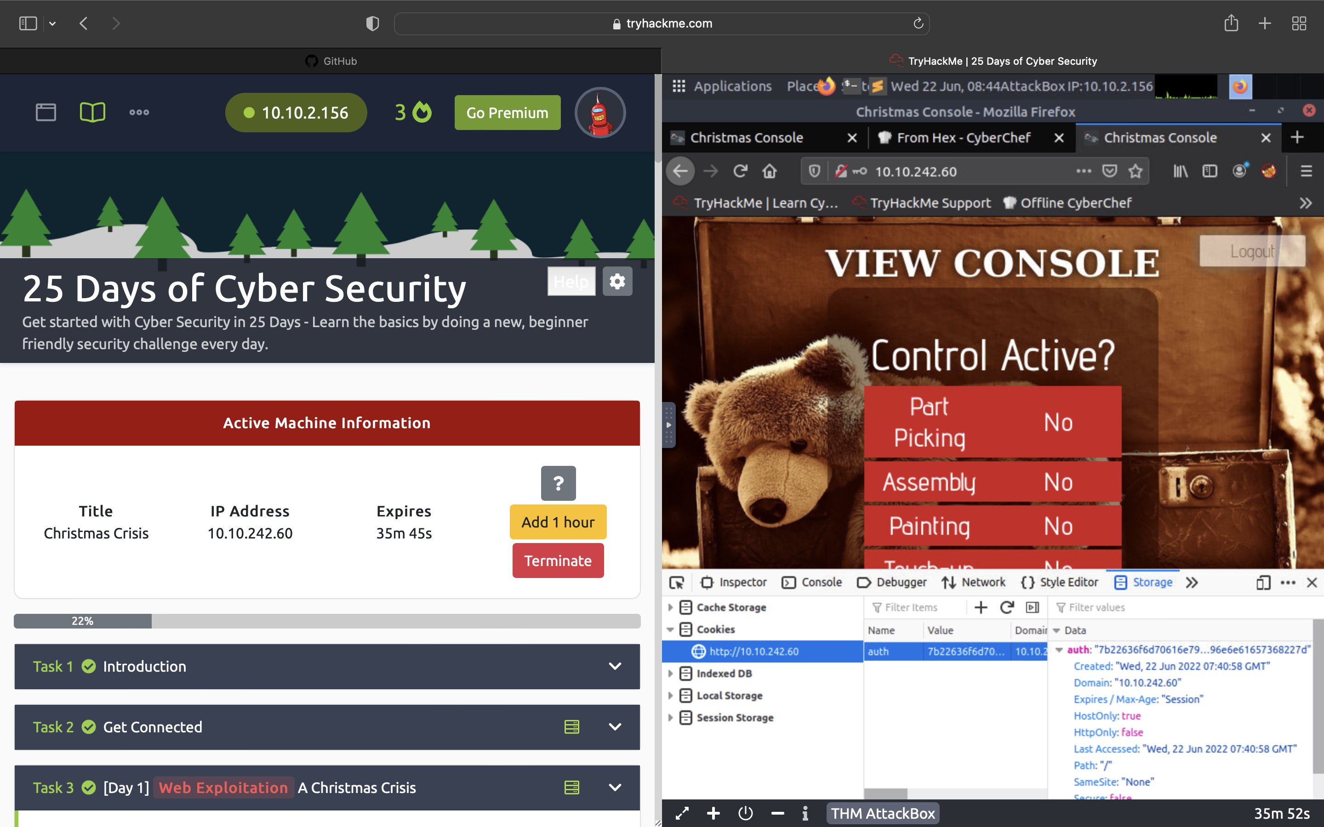

Question 3 :  In what format is the value of this cookie encoded?

* Using Cyberchef, convert the cookie value to a string.

Question 4 : Having decoded the cookie, what format is the data stored in?

* Copy the and paste the cookie value in JSON format and change the username to santa to convert it to hex value and obtain santa’s cookie.

Question 5 : What is the value for the company field in the cookie?

* Decode the cookie value and it will reveal the value of the company field.

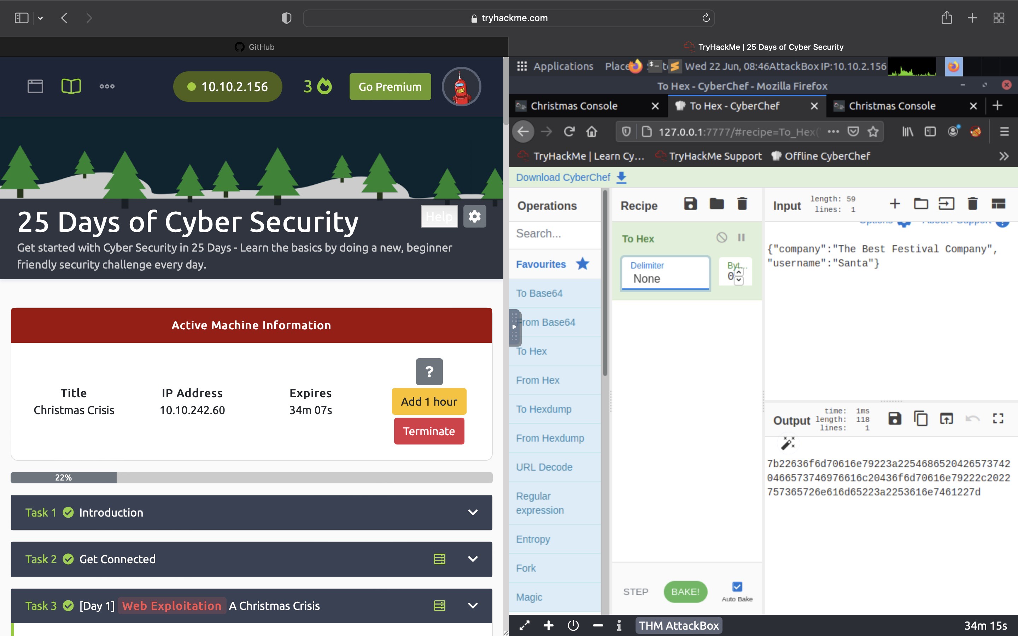

Question 6 : What is the other field found in the cookie?

* Decode the cookie value and it will reveal two fields.



Question 7 : What is the value of Santa's cookie?

* Copy the and paste the cookie value in JSON format and change the username to santa to convert it to hex value and obtain santa’s cookie.



Question 8 : What is the flag you're given when the line is fully active?

* Activate all the controls to reveal the flag.

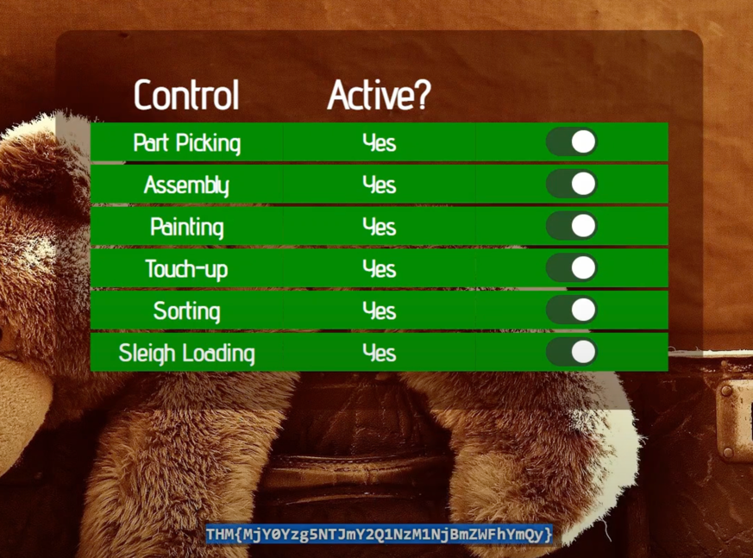

Day 2 – [Web exploitation] The elf strikes back!

Question 1: What string of text needs adding to the URL to get access to

the upload page

* Use “?” to indicate that a GET parameter forthcoming. Enter “id=” with the value of the assigned id number.

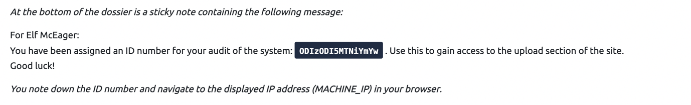

Question 2 - What type of file is accepted by the site

* In the page source code, there is three file type accepted by the upload form.
* The site accepts image file type

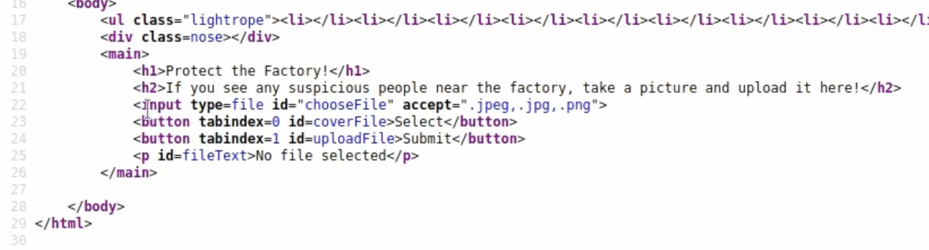

Question 3 - In which directory are the uploaded files stored

* The uploaded files are stored in the “/uploads/” directory.

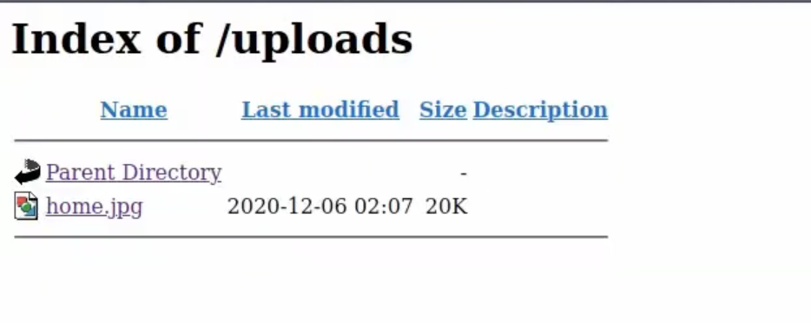

Question 4: What is the flag in /var/www/flag.txt

* Open the flag.txt file from the terminal using the command “cat flag.txt”.
* THM{MGU3Y2UyMGUwNjExYTY4NTAxOWJhMzhh}

Day 3 [web exploitation] Christmas Chaos

Question 1 - What is the name of the botnet mentioned in the text that was reported in 2018?

* Mirai

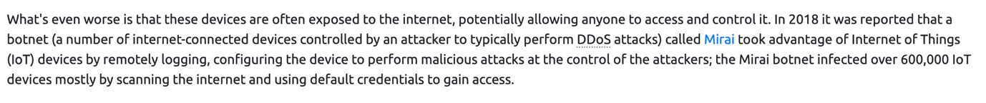

Question 2 -  How much did Starbucks pay in USD for reporting default credentials according to the text

* Starbuck paid 250 USD



Question 3 Read the report from Hackerone ID:804548 - who was the agent assigned from the Dept of Defense that disclosed the report on Jun 25th?

* ag3nt-j1



Question 4 -   Examine the options on FoxyProxy on Burp. What is the port number for Burp?

* The port number for Burp in the options is “8080”

Question 5-  Examine the options on FoxyProxy on Burp. What is the proxy type?

* The proxy type for Burp is SOCKS5

Question 6 - Experiment with decoder on Burp. What is the URL encoding for "PSP0201"?

* Navigate to the decoder tab and type out “PSP0201” and decode the value in URL format.

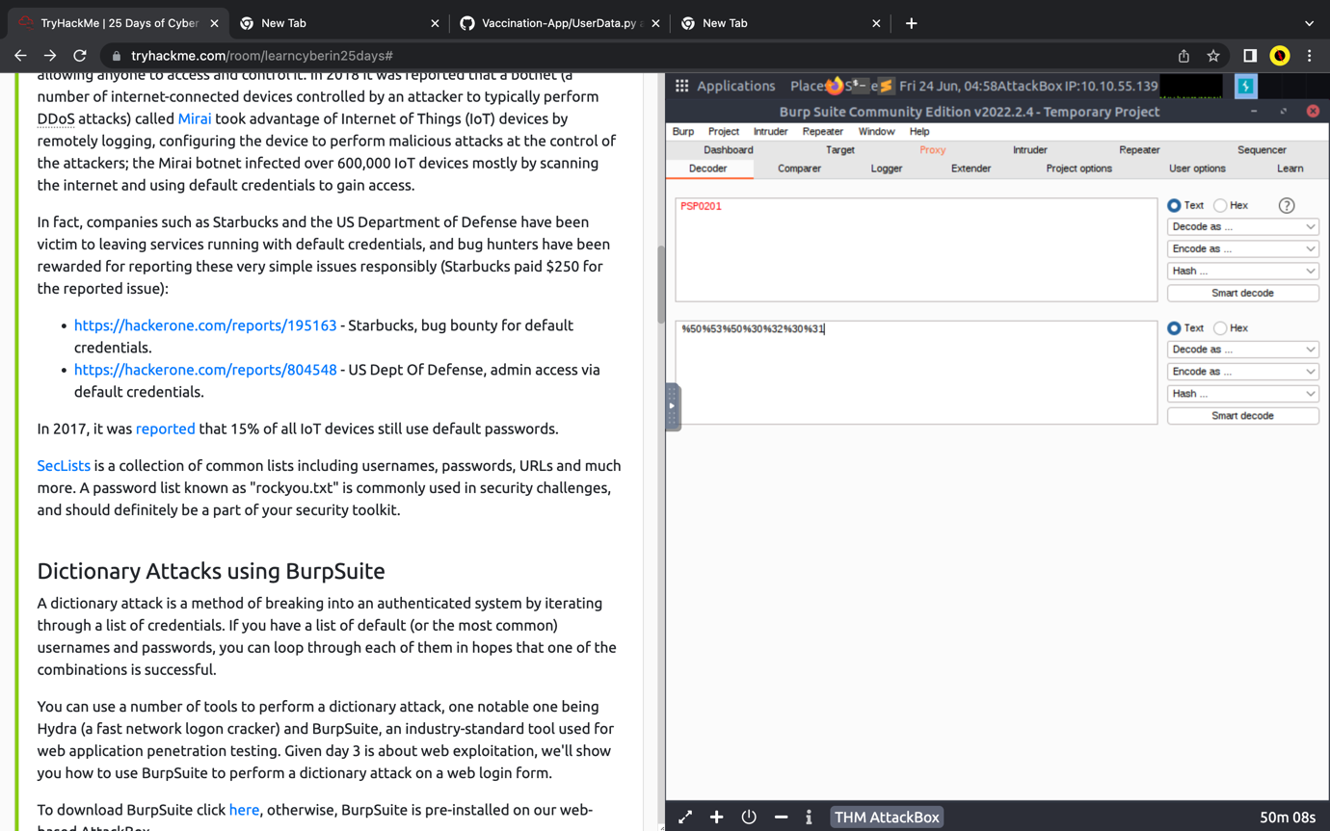

Question 7 -  Look at the list of attack type options on intruder. Which of the following options matches the one in the description?

* Cluster bomb

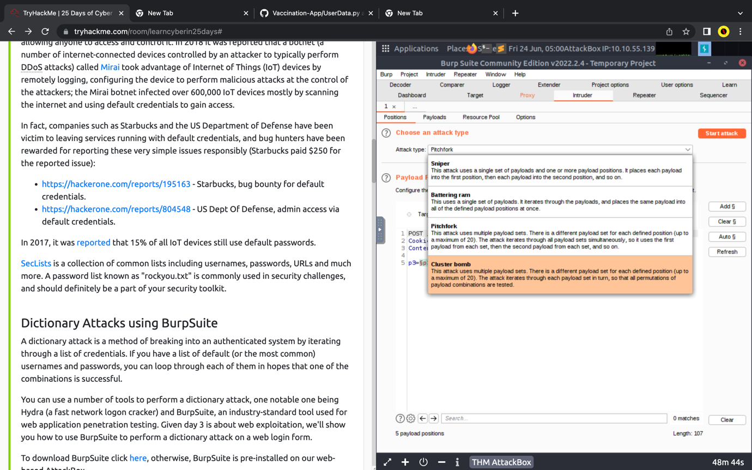

Question 8- What is the flag?

* The flag obtained is THM{885ffab980e049847516f9d8fe99ad1a}

Day 4 – [Web Exploitation] Santa’s Watching

Question 1: Use GoBuster (against the target you deployed -- not

the [shibes.xyz](http://shibes.xyz/) domain) to find the API directory. What file is there?

* Open the terminal and type out the command “gobuster dir -u http://your_ip_adress -w /usr/share/wordlists/big.txt”

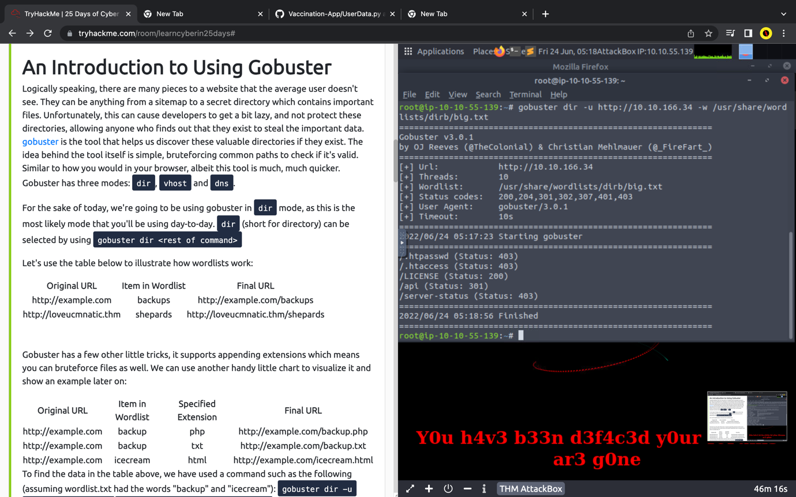

* Open the browser and navigate to the website “your_ip_address/api”

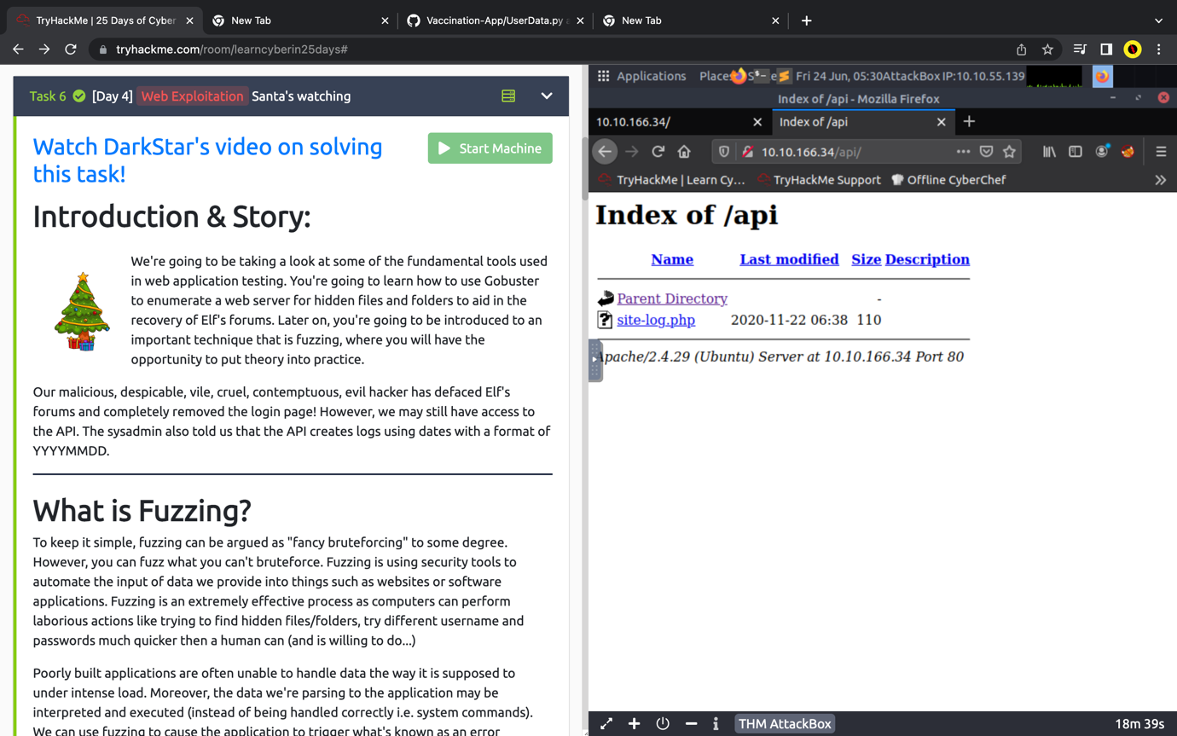

Question 2: Fuzz the date parameter on the file you found in the API directory.

What is the flag displayed in the correct post?

* Use the command “wfuzz -c -z file,/usr/share/wordlists/dirb/big.txt localhost:80/FUZZ/note.txt” to obtain the website directory.

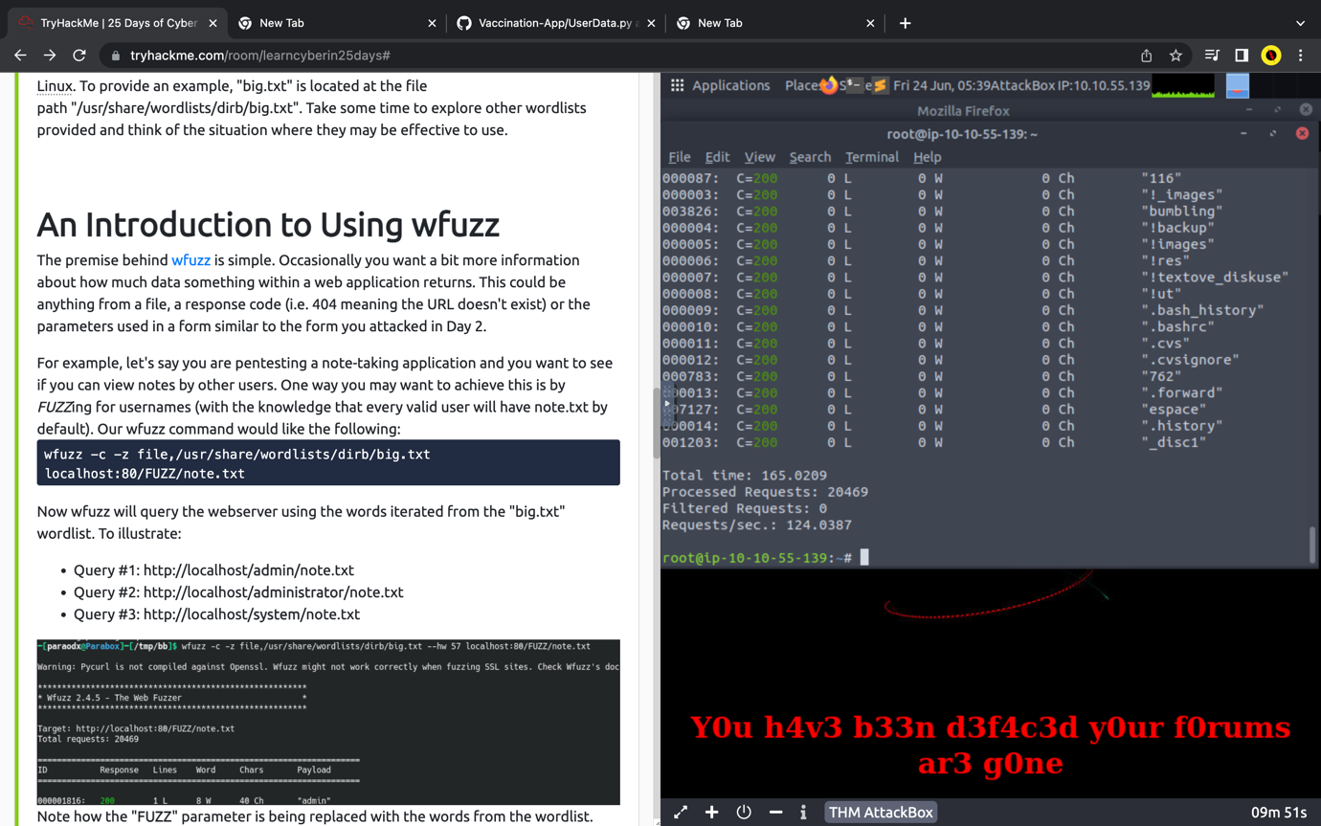

* Enter the date obtained in the url “your_ip_address/api/site-log?date=xxxxxx” to reveal the flag.

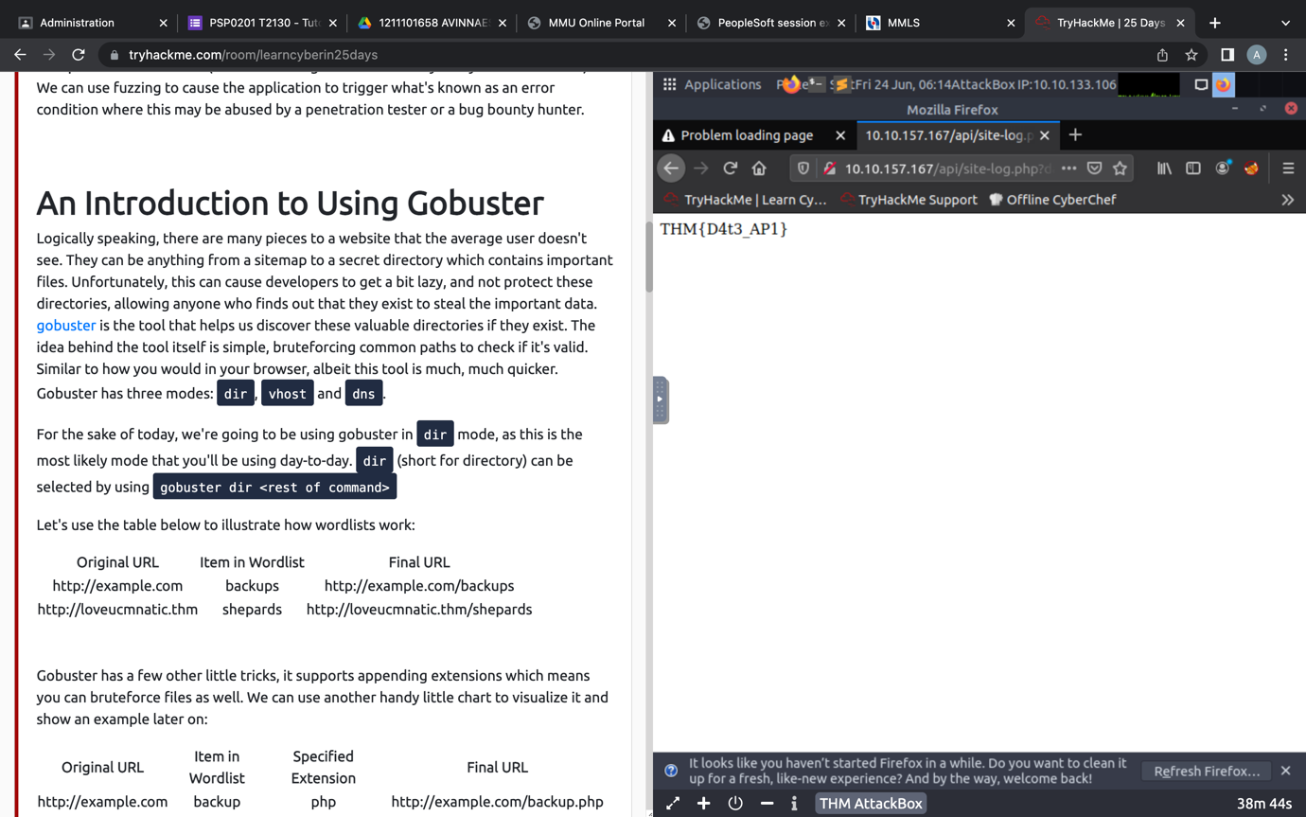

Day 5 – [Web Exploitation] Someone stole Santa’s gift list

Question 1: Without using directory brute forcing, what's Santa's secret

login panel?

* The secret Santa’s login panel was accessed through trial and error.

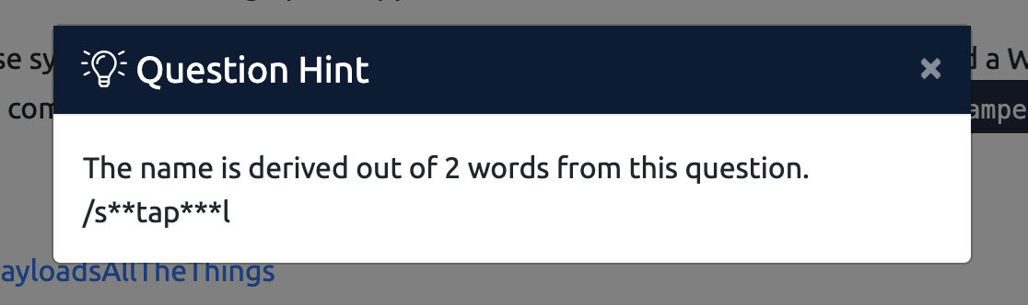

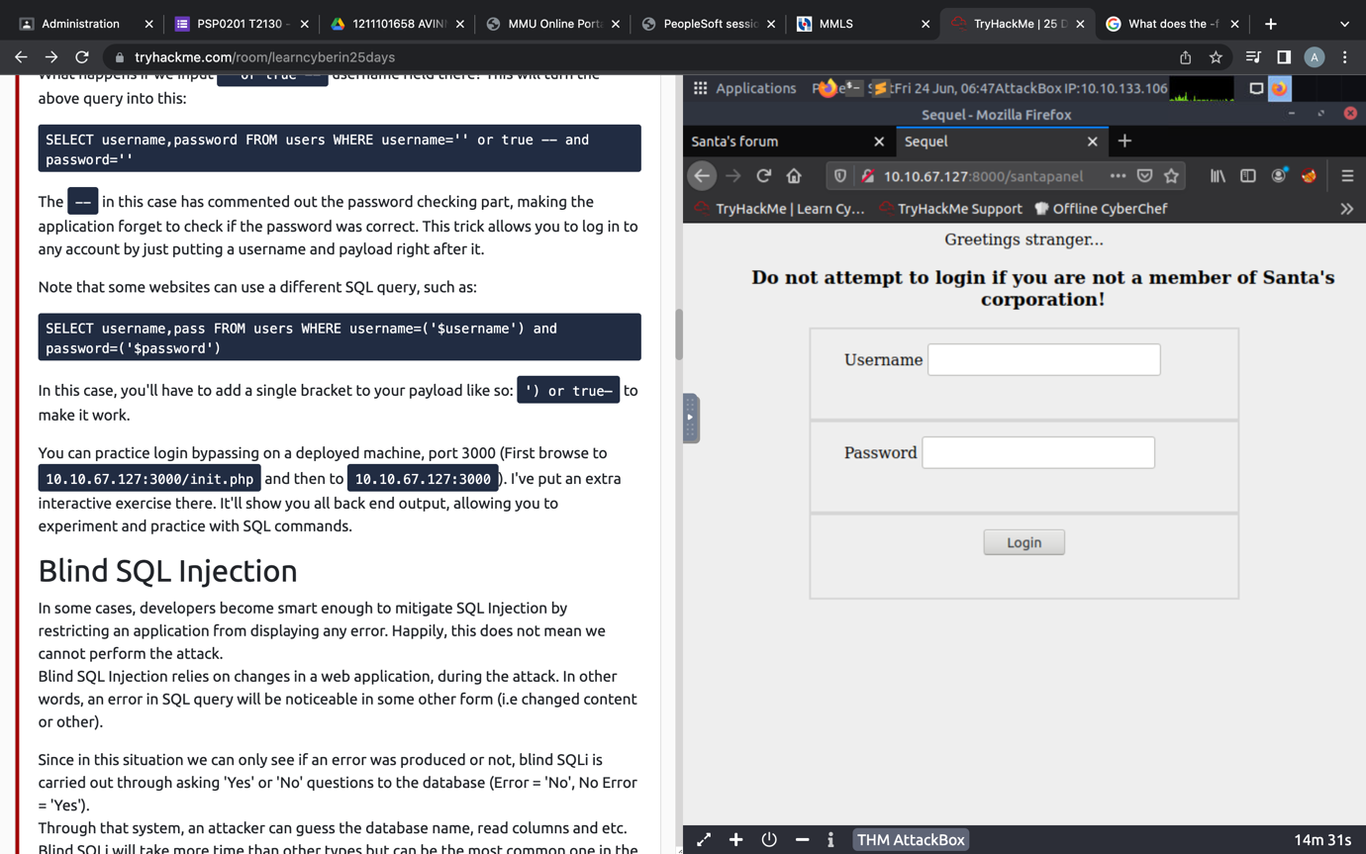

* We do not have access to the website.

Question 2: What is the database used from the hint in Santa's TODO list?

* Sqlite



Question 3: How many entries are there in the gift database?

* Open the browser and type out the url “your_ip_address:3000 to get into the login bypass page.
* Enter the username as “anything’ or true --“ and the password as “12345”.

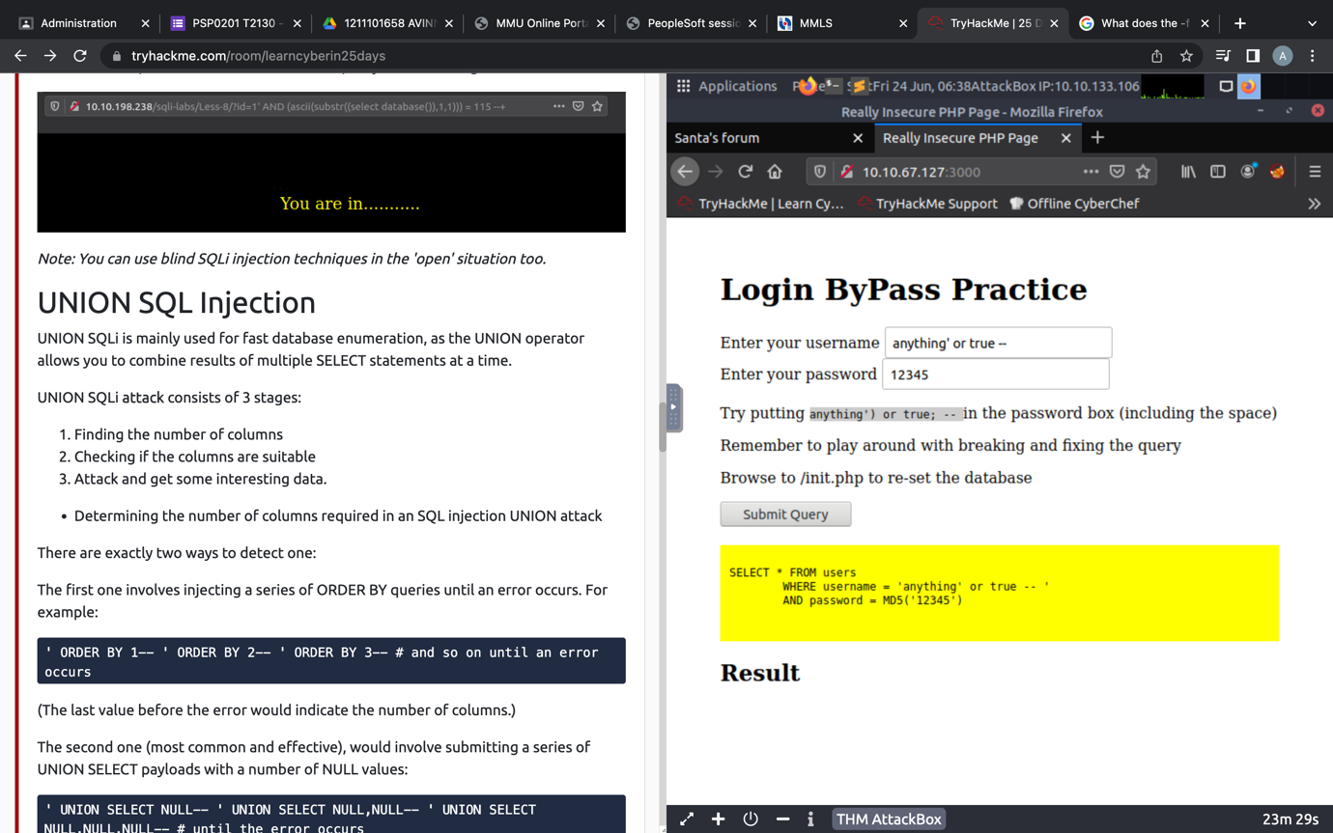

* Then go to the website “your_ip_address:8000/santapanel”, enter the username and password to login.

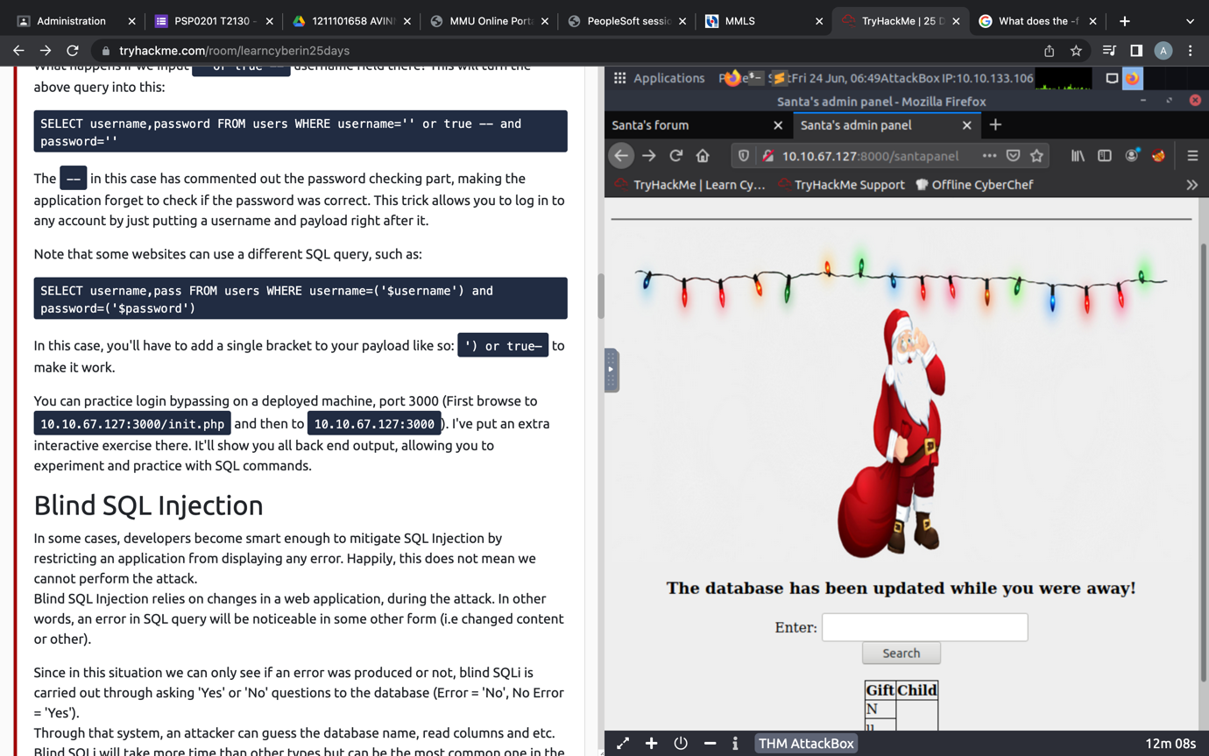

* Turn on the Burp proxy on the website and open the burp app.
* Do a search through the database.
* Turn on the intercept on Burp and save the item under panel.request.

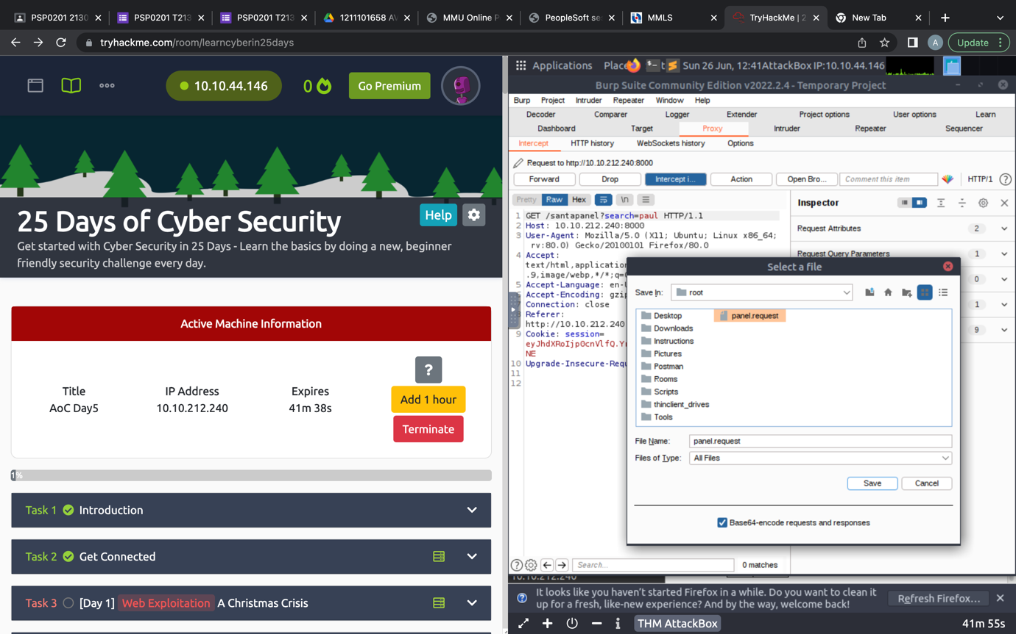

* Open the terminal and run the command “sqlmap -r panel.request –tamper=space2comment –dump-all –dbms sqlite.

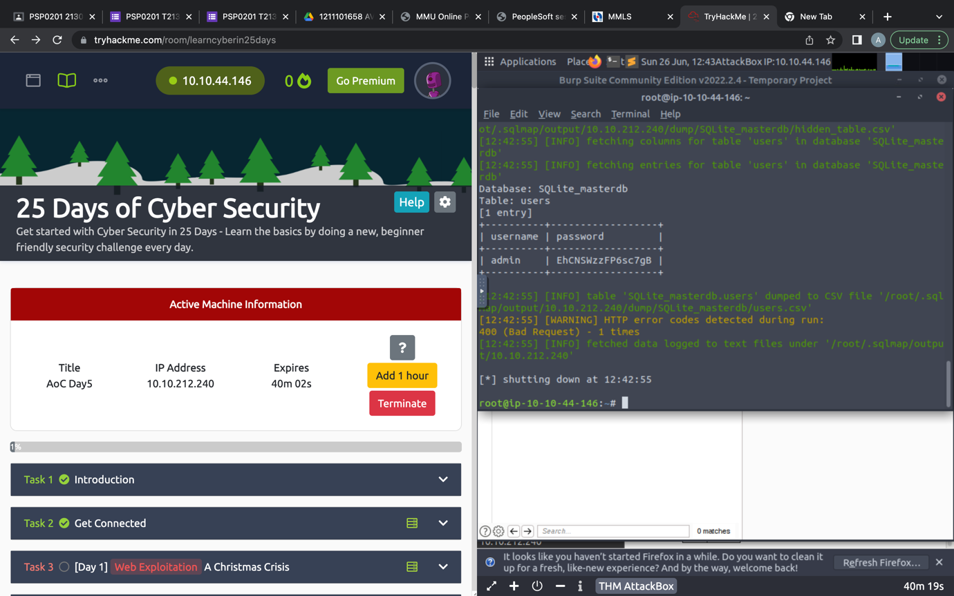

* There will be 22 entries in the database.

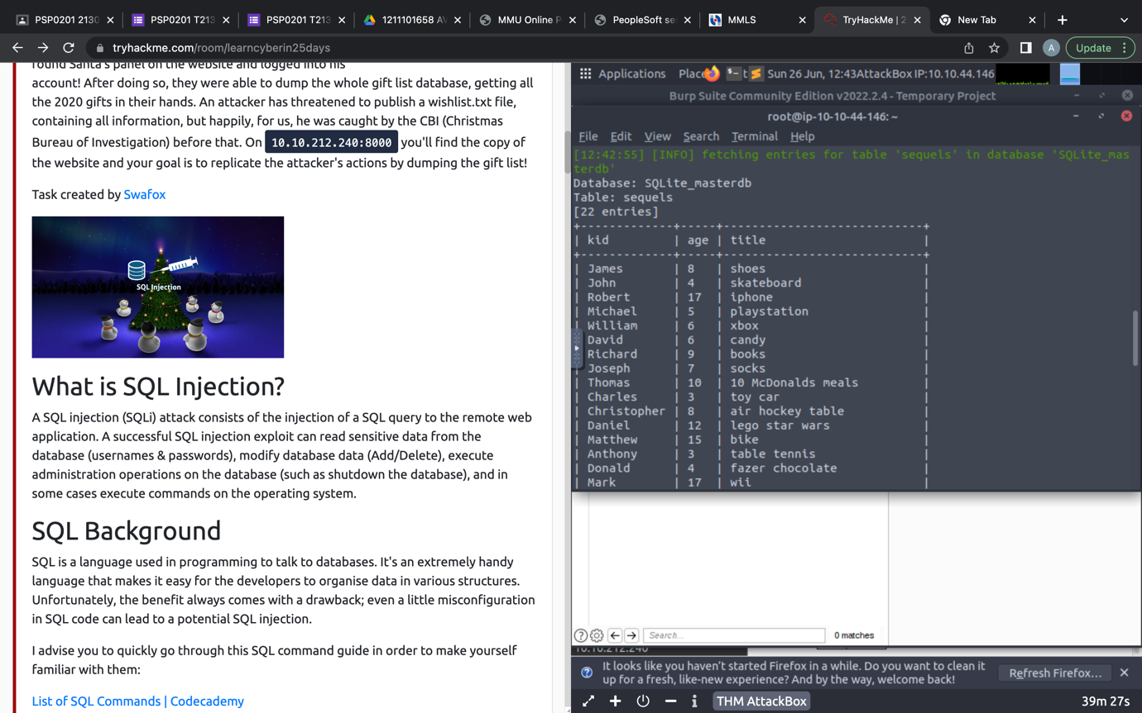

Question 4: What is James' age?

* James’ age can be found in the table.

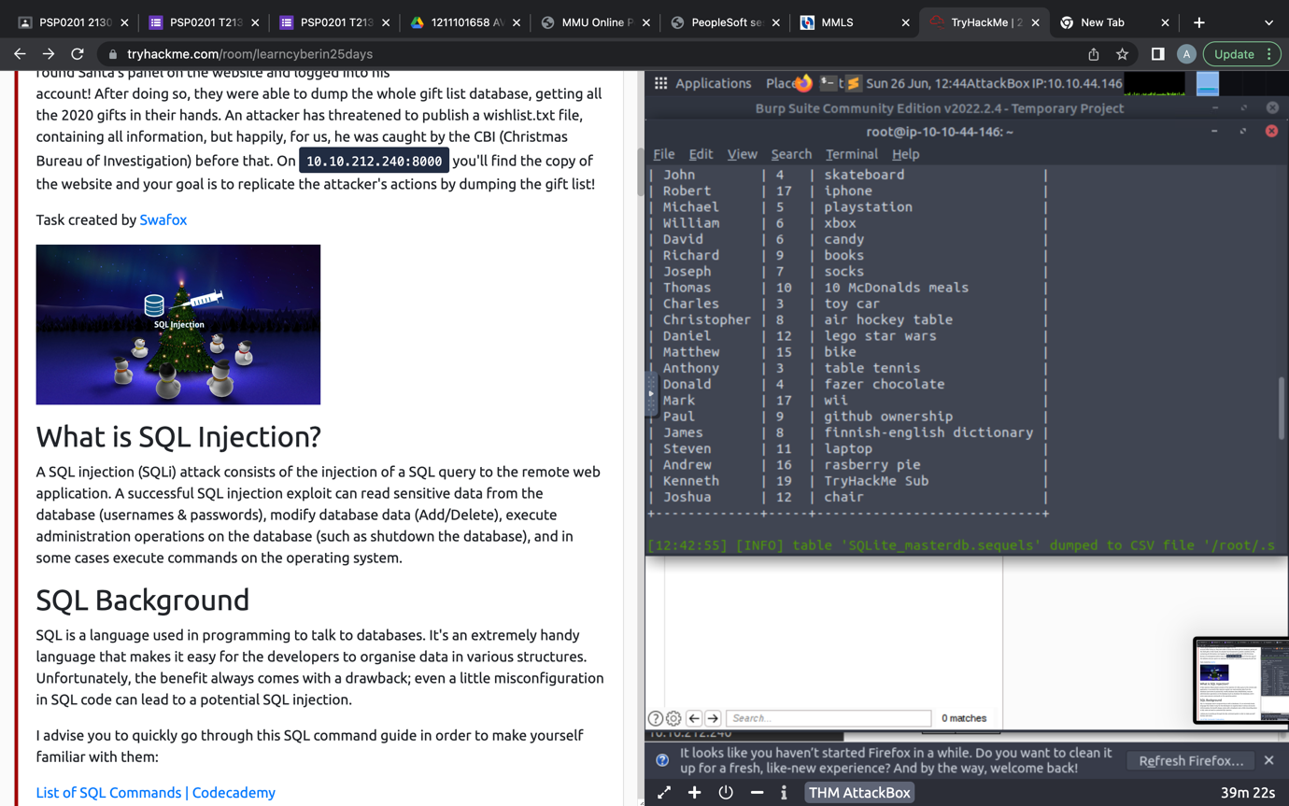

Question 5: What did Paul ask for?

* Paul asked for github ownership based on the same table



Question 6:  What is the flag?

* The flag can be obtained in the hidden table

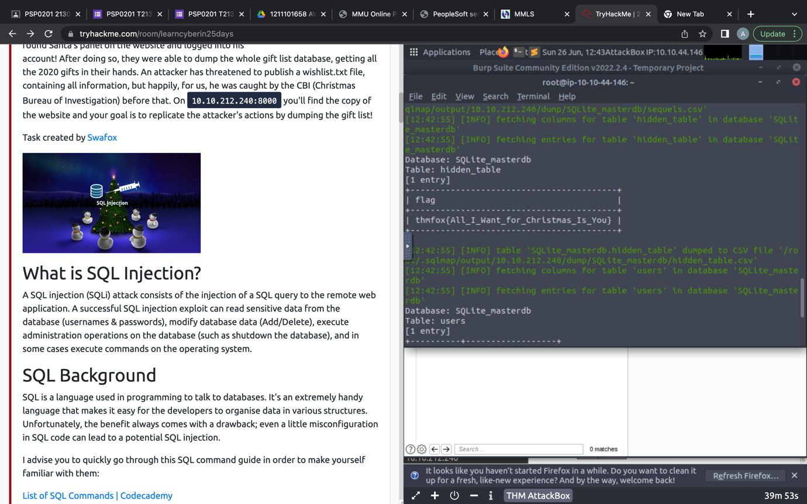

Question 7: What is admin's password?

* The admins password can be found in the users table

